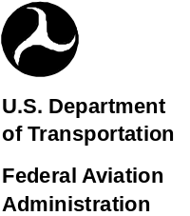 | Windsor Locks Flight Standards District Office  Windsor Locks, Connecticut  Aviation Safety Program  Aviation Safety Education Seminar  KENNETH D. ROACH-MANAGER-WINDSOR LOCKS FLIGHT STANDARDS DISTRICT OFFICE  PETER LINDBERG (860) 654-1033 SAFETY PROGRAM MANAGER  Peter.Lindberg@faa.gov
NE03
POST IN A PROMINENT LOCATION SO YOU DON'T MISS ANY OF THIS MONTH'S
SEMINARS---WHY NOT TAKE A FRIEND TO YOUR NEXT SEMINAR?
ALL PROGRAMS ARE FREE OF CHARGE AND OPEN TO THE PUBLIC
MAY 2006

FAA’S PILOT PROFICIENCY AWARDS PROGRAM “WINGS”
Sun | Mon | Tue | Wed | Thu | Fri | Sat
 | 1 | 2  Plainville, CT  Pre-Flight | 3 | 4 | 5 | 6
7 | 8 | 9 | 10 | 11  Hartford, CT  CFI Workshop/  Royal Griffin DPE | 12 | 13 SAFETY FEST MAINTENANCE 2006. P&W E. Hartford, CT
14 | 15 | 16  Bridgeport, CT  Pre-Flight | 17 | 18  Westfield, MA  Pre-Flight | 19 | 20
21 | 22  Danbury CT  Pre-Flight | 23 | 24 | 25  Northampton, MA  Pre-Flight | 26 | 27
28 | 29 | 30 | 31
Who may participate? Pilots holding a private certificate or higher. Includes: airplanes, seaplanes, rotorcraft, gliders, lighter than air, and ultralights. Why participate? Regular proficiency training is essential to the safety of all pilots. In addition, completion of the “WINGS” program satisfies the requirements of FAR 61.56 (Flight Review). Be in touch with your strengths and weaknesses. What are the requirements? Attend an FAA sponsored safety seminar and receive 3 hours of flight instruction; an hour each on: take offs and landings, instrument flying, and basic airwork. All requirements must be completed within a 12-month period. Every 12 months, you can achieve another phase of the “WINGS” program. The requirements are the same for each phase. Receive a set of “WINGS” and a certificate for each phase. Consult Advisory Circular 61-91H for details.

(1)
MARK YOUR CALENDARS: Saturday, May 13, 2006 SAFETY FEST/MAINTENANCE FEST 2006 8:30am-3:30pm
Featuring Ms. Carol Ann Garratt who will share with us her seven month long trip around the world in a Mooney M20-J.
AOPA’s “Do the right thing” seminar, EAA’s
“learn a skill” area, Sport Pilot/Light Sport Aircraft seminars, static display aircraft, maintenance training, pilot workshops, aviation vendors, and more!
Pratt & Whitney’s Customer Training Center, East Hartford, CT

PRE-FLIGHT
TUESDAY, MAY 2, 2006 @ 7:30 PM
INTERSTATE AVIATION/ROBERTSON FIELD/PLAINVILLE, CT

Every good flight starts with a good preflight. Airworthiness Safety Program Manager Pete Lindberg will talk
about preflighting your aircraft.

SPONSORED BY INTERSTATE AVIATION
Contact: Bob Nardiello (800) 573-5519
~~~~~~~~~~~~~~~~~~~~~~~~~~~~~~~~~~~~~~~~~~~~~~~~~~~~~~
CFI WORKSHOP/Royal Griffin DPE
THURSDAY, MAY 11, 2006 @ 7:30 PM
DEPT OF PUBLIC SAFETY/DIVISION OF HOMELAND SECURITY HANGAR/269 MAXIM RD
BRAINARD FIELD/HARTFORD, CT (Park at east end of hangar)

Royal Griffin, DPE will review flight testing procedures.

SPONSORED BY PROFESSIONAL FLIGHT TRAINING/ DEPT OF PUBLIC SAFETY/DIVISION OF HOMELAND SECURITY
Contact: Gary Ciriello (860) 724-2245
~~~~~~~~~~~~~~~~~~~~~~~~~~~~~~~~~~~~~~~~~~~~~~~~~~~~~~
SAFETY FEST / MAINTENANCE FEST
SATURDAY, MAY 13, 2006 @ 8:30 AM 3:30 PM
PRATT & WHITNEY CUSTOMER TRAINING CENTER AND HANGAR AND ENGINE MUSEUM, EAST HARTFORD, CT

SEE PAGE 4

SPONSORED BY UNITED TECHNOLOGIES PRATT & WHITNEY, FEDERAL AVIATION ADMINISTRATION, PRIVATAIR, BOMBARDIER, PROFESSIONAL AVIATION MAINTENANCE ASSOCIATION
Contact: Peter Lindberg (860)654-1033, (Peter.Lindberg@FAA.GOV)
~~~~~~~~~~~~~~~~~~~~~~~~~~~~~~~~~~~~~~~~~~~~~~~~~~~~~~~~~~~~~
PRE-FLIGHT
TUESDAY, MAY 16, 2006 @ 7:30 PM
THREE WING FLYING SERVICE/400 GREAT MEADOW DRIVE / SIKORSKY MEMORIAL AIRPORT/STRATFORD, CT

Every good flight starts with a good preflight. Airworthiness Safety Program Manager Pete Lindberg
will talk about preflighting your aircraft.

SPONSORED BY THREE WING FLYING SERVICE
Contact: David Faile (FOSAemail@aol.com)
Contact: Tim Brady (203) 331-3306
~~~~~~~~~~~~~~~~~~~~~~~~~~~~~~~~~~~~~~~~~~~~~~~~~~~~~~~~~~~~~

(2)

PRE-FLIGHT
THURSDAY, MAY 18, 2006, NOTE 7:30 PM Start Time
FIVE STAR JET ACADEMY / BARNES AIRPORT / WESTFIELD, MA.

Every good flight starts with a good preflight. Airworthiness Safety Program Manager Pete Lindberg
will talk about preflighting your aircraft.

SPONSORED BY Five Star Jet Academy
Contact: Mike Foy (413) 568-5800
~~~~~~~~~~~~~~~~~~~~~~~~~~~~~~~~~~~~~~~~~~~~~~~~~~~~~~~~~~~~~
PRE-FLIGHT
MONDAY, MAY 22, 2006 @7:30 PM
MIRY BROOK VOLUNTEER FIRE HOUSE/MIRY BROOK ROAD/DANBURY AIRPORT/DANBURY, CT

Every good flight starts with a good preflight. Airworthiness Safety Program Manager Pete Lindberg
will talk about preflighting your aircraft.

SPONSORED BY 399TH COMPOSITE SQUADRON-CIVIL AIR PATROL
MIRY BROOK VOLUNTEER FIRE DEPT
Contact: Tony Debany (914) 588-1682
~~~~~~~~~~~~~~~~~~~~~~~~~~~~~~~~~~~~~~~~~~~~~~~~~~~~~~~~~~~~~

PRE-FLIGHT
THURSDAY, MAY 25, 2006 @7:30 PM
NORTHAMPTON AERONAUTICS INCORPORATED / 160 OLD FERRY ROAD/NORTHAMPTON, MA

Every good flight starts with a good preflight. Airworthiness Safety Program Manager Pete Lindberg
will talk about preflighting your aircraft.

SPONSORED BY NORTHAMPTON AERONAUTICS INC.
Contact: SARAH CARPENTER (413) 584-7980
~~~~~~~~~~~~~~~~~~~~~~~~~~~~~~~~~~~~~~~~~~~~~~~~~~~~~~~~~~~~~

Looking for the closest Aviation Medical Examiner to where you work or live?
Try http://www.faa.gov/pilots/amelocator/

Need TFR information, FAA publications, forms, employment information, etc? Check out www.faa.gov for a wealth of information that is readily available to you.

FAA Safety Program Airmen Notification System (SPANS)
- Provides airmen with Safety Program information and notification in the timeliest manner possible.
- Provides easy access to safety seminar and event information and online registration where appropriate.
- Provides an easy way for airmen to make important suggestions to the Safety Program.

WE NEED YOU TO REGISTER NOW AT: http://faasafety.gov/

Other local sources of seminar information include:
- The Atlantic Flyer aviation newspaper or Aviation Digest

(3)

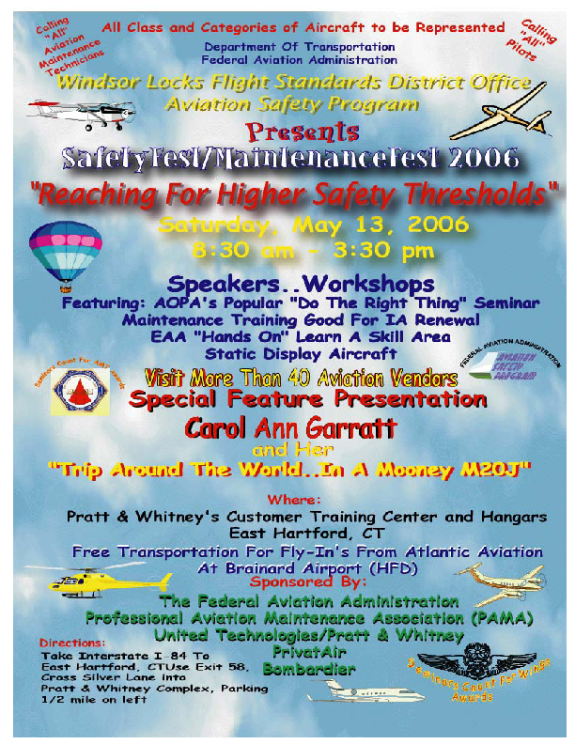

EARN YOUR WINGS! Regular proficiency training is essential to the safety of all pilots and their passengers. The objective of the Pilot Proficiency Awards Program is to provide pilots with the opportunity to establish and participate in a personal recurrent training program. Join your fellow pilots who recognize the need for recurrent flight training. Congratulations to this month’s recipients.

PHASE I | PHASE III | PHASE VII | PHASE X
Kirk Morris | Thomas Humbert | Kent Sykes | George Constantine
Tony Woolner | David Cohen |  | James Evans
Jill Silverman | Joseph Giordano | PHASE VIII | PHASE XII
Daniel Lourenco |  | William Lucas | William Piggott
Bruce Dixon | PHASE IV | Mark Freeman
Gregory Castanza | Mark Winne |  | PHASE XIII
 | Ralph Sather |  | Richard Howland

PHASE II
Michael Kwas | PHASE V |  | PHASE XVII
 | William Hewett | PHASE IX | Keith Neilson
 | Raymond Vidito | Edmund Carroll Jr.
 | Raymond Garnsey
Remember, if you satisfactorily complete a phase of the WINGS program within the period specified by Section 61.56 of the Federal Aviation Regulations, you need not complete a flight review.
DON'T COME ALONE, CALL A FRIEND AND REMIND THEM OF OUR SEMINARS.
STUDENT PILOTS WELCOME!

A pilot is only as good as their next flight! We can never get too much training.

Looking for TFR information, FAA publications, forms, employment information, etc? Check out www.faa.gov for a wealth of information that is readily available to you.

